- Area

1. Calculate the area of the shaded region below, given that AC is an arc of a circle centre B. AB=BC=14cm CD=8cm and angle ABD = 75⁰ (4 mks)
75⁰
A
C
B
B
8 cm
14 cm
14 cm

2 The scale of a map is 1:50000. A lake on the map is 6.16cm². find the actual area of the lake in hactares. (3mks)
3. The figure below is a rhombus ABCD of sides 4cm. BD is an arc of circle centre C. Given that ∠ABC = 138⁰. Find the area of shaded region. (3mks)
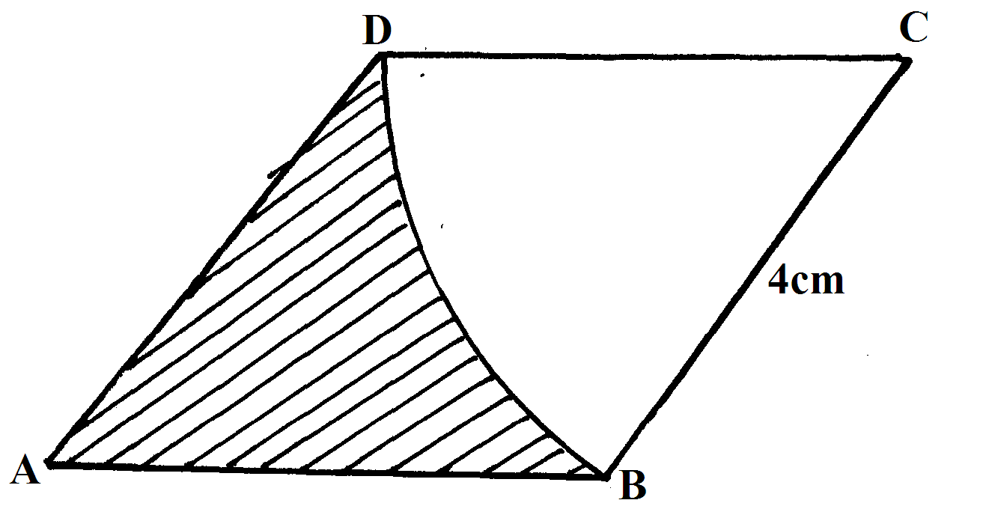
4. The figure below sows the shape of Kamau’s farm with dimensions shown in meters
140m
20 m
80m
100m

Find the area of Kamau’s farm in hectares (3mks)
5. In the figure below AB and AC are tangents to the circle centre O at B and C respectively,
the angle AOC = 60⁰

Calculate
(a) The length of AC (2 marks)

6. The figure below shows the floor of a hall. A part of this floor is in the shape of a rectangle of length 20m and width 16m and the rest is a segment of a circle of radius 12m. Use the figure to find:-
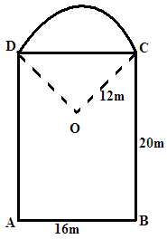
(a) The size of angle COD (2mks)
(b) The area of figure DABCO (4mks)
(c) Area of sector ODC (2mks)
(d) Area of the floor of the house. (2mks)
END
7. The circle below whose area is 18.05cm² circumscribes a triangle ABC where AB = 6.3cm, BC = 5.7cm and AC = 4.8cm. Find the area of the shaded part (4 mks)
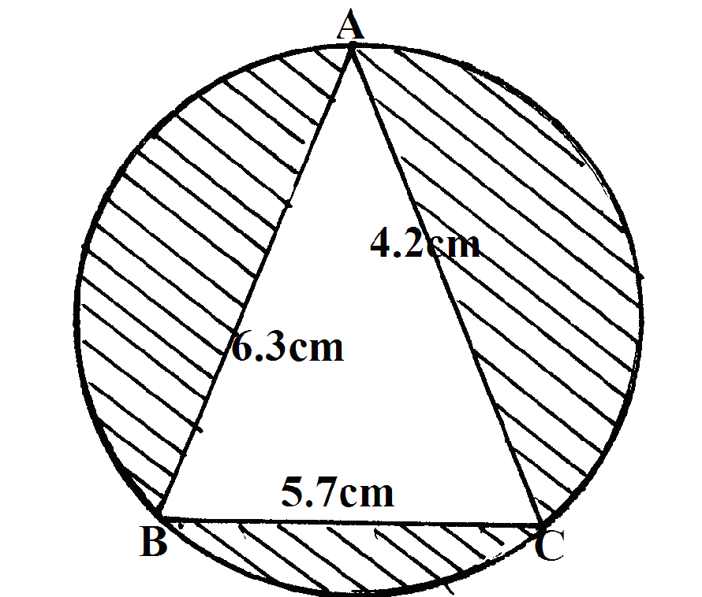
8. In the figure below, PQRS is a rectangle in which PS=10k cm and PQ = 6k cm. M and N are midpoints of QR and RS respectively

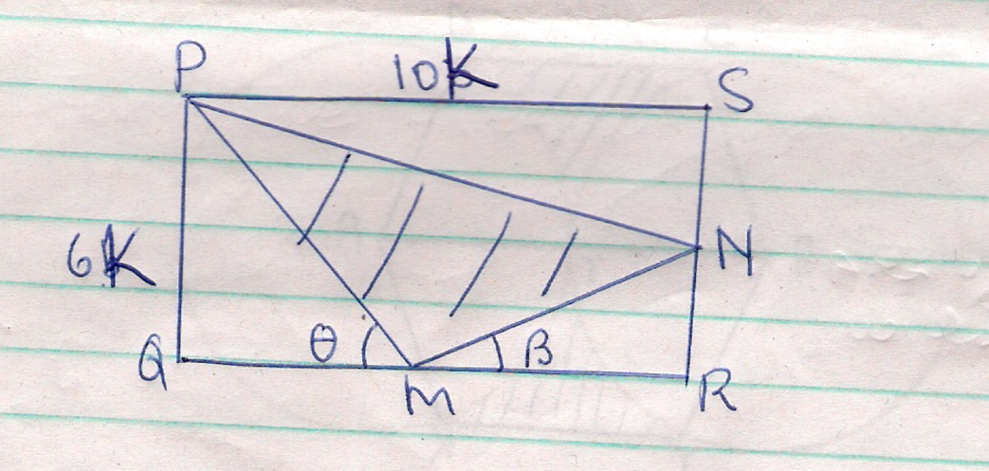

    - Find the are of the shaded region (4 marks)
    - Given that the area of the triangle MNR = 30 cm². find the dimensions of the rectangle (2 marks)
    - Calculate the sizes of angles and  giving your answer to 2 decimal places (4 marks)
9. The figure below shows two circles each of radius 10.5 cm with centres A and B. the circles touch each other at T

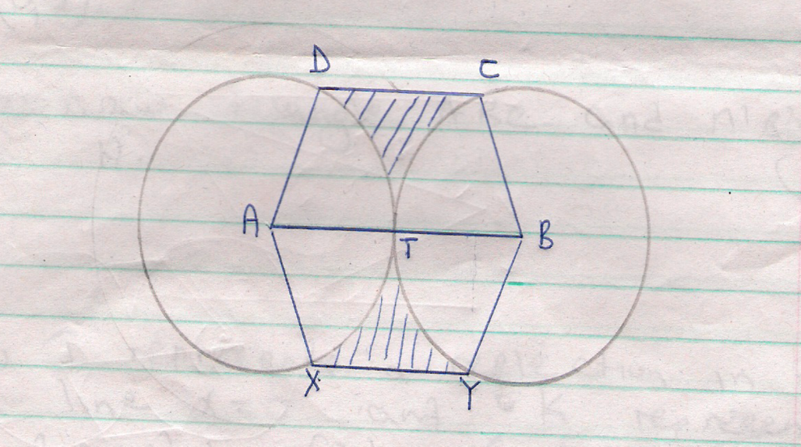
Given that angle XAD =angle YBC = 160⁰ and lines XY, ATB and DC are parallel, calculate the area of:
    - The minor sector AXTD (2 marks)
    - Figure AXYBCD (6marks)
    - The shaded region (2 marks)
10. A student took the measurements of his classroom and gave the width as 7m and the length as 9m.
If there is an error of 2% in each measurement, determine the greatest value of x + y
x
if x and y are the width and length of the classroom respectively.
Give your answer to 4 decimal places.

11. The floor of a room is in the shape of a rectangle 10.5 m long by 6 m wide. Square tiles of
length 30 cm are to be fitted onto the floor.
(a) Calculate the number of tiles needed for the floor.
(b) A dealer wishes to buy enough tiles for fifteen such rooms. The tiles are packed in cartons
each containing 20 tiles. The cost of each carton is Kshs. 800. Calculate
(i) the total cost of the tiles.
(ii) If in addition, the dealer spends Kshs. 2,000 and Kshs. 600 on transport and subsistence
respectively, at what price should he sell each carton in order to make a profit of 12.5%
(Give your answer to the nearest Kshs.)

12. The figure below is a circle of radius 5cm. Points A, B and C are the vertices of the triangle
ABC in which ∠ABC = 60º and ∠ACB=50º which is in the circle. Calculate the area of ΔABC )
A
C
B
60º
50º

13. Mr.Wanyama has a plot that is in a triangular form. The plot measures 170m, 190m
and 210m, but the altitudes of the plot as well as the angles are not known. Find the area
of the plot in hectares

14. Three sirens wail at intervals of thirty minutes, fifty minutes and thirty five minutes.
If they wail together at 7.18a.m on Monday, what time and day will they next wail together?

15. A farmer decides to put two-thirds of his farm under crops. Of this, he put a quarter under
maize and four-fifths of the remainder under beans. The rest is planted with carrots.
If 0.9acres are under carrots, find the total area of the farm
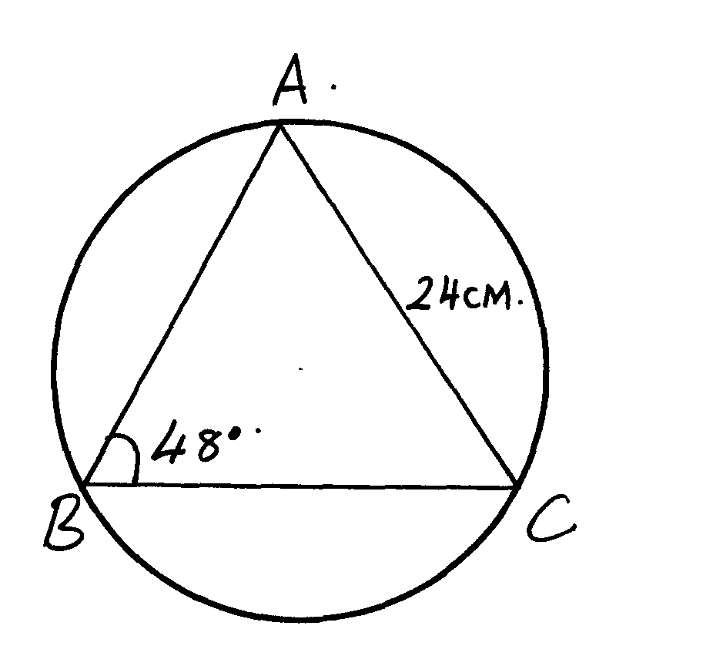
16. Find the area of the circle sector.

